**EXCELL ASSIGNMENT -10**

**QUESTION 1,2 .**

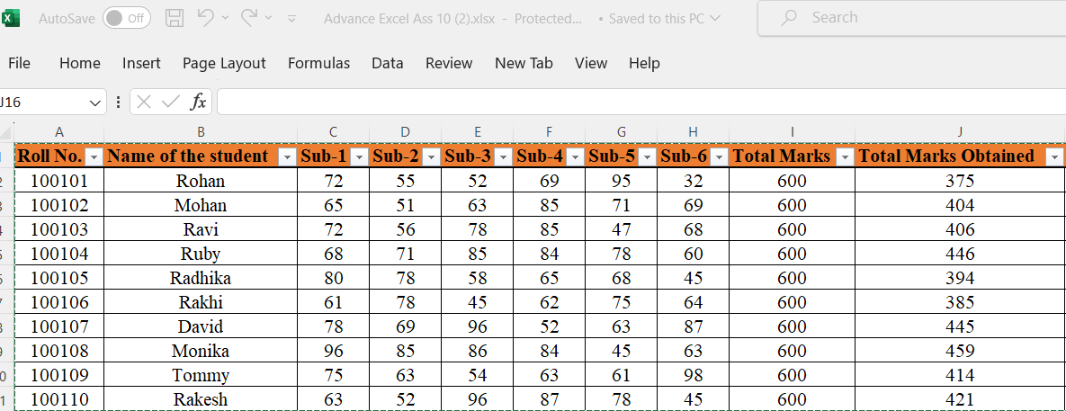

**QUESTION 3. Calculate Average for each student in the next row. Use Formulas.**

**ANSWER =**

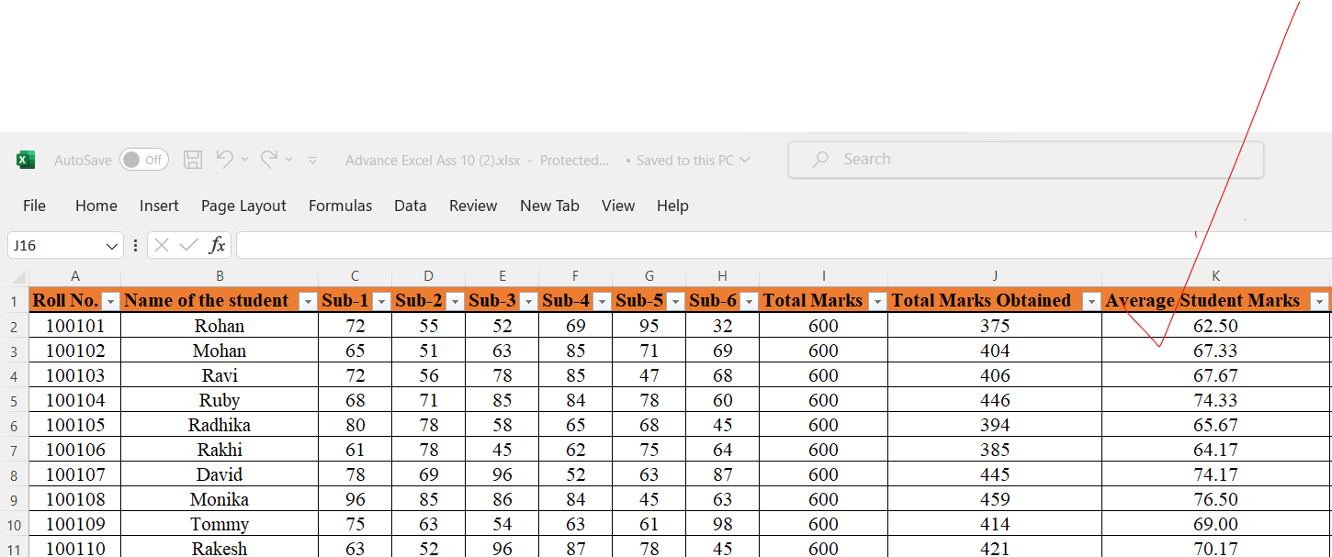

**QUESTION 4. Calculate Rank for each student. Use Formulas.**

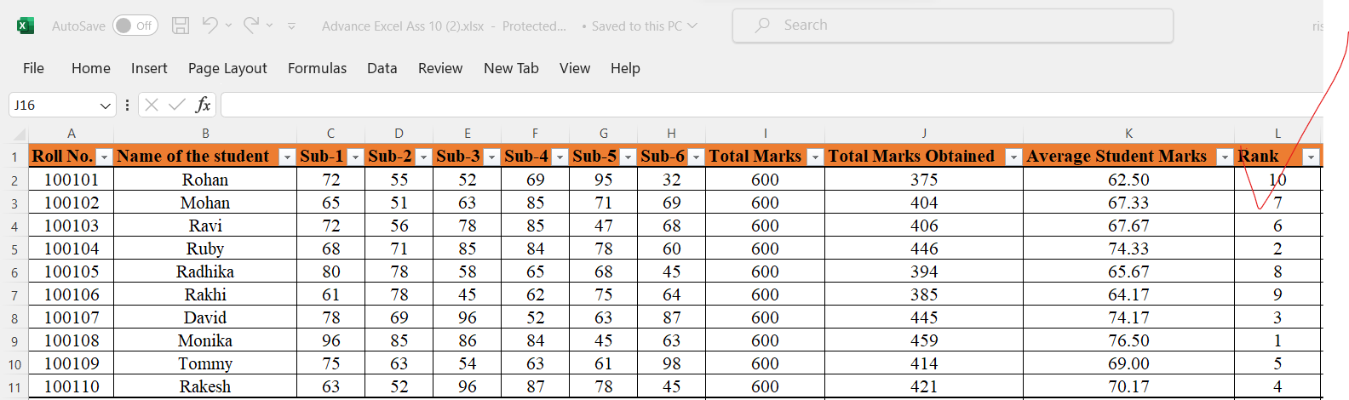

**QUESTION 5.**  **Calculate Percentage for each student. Use Formulas. Round off the decimals up to 2 points.**

**ANSWER=**

